# Project Report

**IBM-Project-39025-1660389388**

University Admit Eligibility Predictor

# INTRODUCTION

###### Project Overview

The problem statement is to design a college prediction/ prediction system and to provide a probabilistic insight into college administration for overall rating, cut-offs of the colleges, admission intake and preferences of students.

It has always been a troublesome process for students in finding the perfect university and course for their further studies.

At times they do know which stream they want to get into, but it is not easy for them to find colleges based on their academic marks and other performances.

We aim to develop and provide a place which would give a probabilistic output of how likely it is to get into a university given their details.

###### Purpose

* Students are often worried about their chances of admission to University.
* The aim of this project is to help students in shortlisting universities with their profiles.
* The predicted output gives them a fair idea about their admission chances to a particular university.
* This analysis should also help students who are currently preparing or will be preparing to get a better idea.

# LITERATURE SURVEY

### Existing problem

###### We have so many websites with problems in inaccuracy and not getting the right thing out.

* Our project, which is based on University Admit Eligibility Predictor, with a great accuracy mark, gives the output more effectively and efficiently.

### References

* P.KaviPriya**, “**A Review on Predicting Students’ Academic Performance Earlier, Using Data Mining Techniques”, International Jour-nal of Advanced Research in Computer Science and Software Engineering
* Ali Daud, Naif Radi Aljohani, “Predicting Student Performance using Advanced Learning Analytics”, 2017 International World Wide Web Conference Committee (IW3C2).
* Marium-E-Jannat,SaymaSultana,Munira Akther, “A Probabilistic Machine Learning Approach for Eligible Candidate Selection”, Inter-national Journal of Computer Applications (0975 – 8887)Volume 144 – No.10, June 2016
* Sudheep Elayidom, Dr. Sumam Mary Idikkula, “Applying Data mining using Statistical Techniques for Career Selection”, International Journal of Recent Trends in Engineering, Vol. 1, No. 1, May 2009.
* Dr. Mahendra Tiwari ,Manmohan Mishra, “Accuracy Estimation of Classification Algorithms with DEMP Model”, International Jour-nal of Advanced Research in Computer and Communication Engineering Vol. 2, Issue 11, November 2013.
* Ms. Roshani Ade,Dr. P. R. Deshmukh, “An incremental ensemble of classifiers as a technique for prediction of student’s career choice”, 2014 First International Conference on Networks & Soft Compu-ting
* Nikita Gorad ,Ishani Zalte, “Career Counselling Using Data Mining”, International Journal of Innovative Research in Computer and Communication Engineering.
* Bo Guo , Rui Zhang, “Predicting Students Performance in Educa-tional Data Mining”,2015 International Symposium on Educational Technology
* Ali Daud , Naif Radi Aljohani , “Predicting Student Performance using Advanced Learning Analytics”
* Rutvija Pandya Jayati Pandya , “C5.0 Algorithm to Improved KNN with Feature Selection and Reduced Error Pruning“, Inter-national Journal of Computer Applications (0975 – 8887) Volume 117

– No. 16, May 2015.

* Comparative Analysis of KNN Algorithms: ID3, C4.5 and KNNShiju Sathyadevan and Remya R. Nair
* Yu Lou, Ran Ren, “A Machine Learning Approach for Future Ca-reer Planning”
* Gareth James ,Daniela Witten ,Trevor Hastie, ”An Introduction to Statistical Learning with Applications in R”
* Anuj Karpatne, Gowtham Atluri, “Theory- Guided Data Science: A New Paradigm for Scientific Discovery from Data”, IEEE trans-actions on knowledge and data engineering, vol.29, no. 10, october 2017.

### Problem Statement Definition

**Problem Statement**

* + - The problem statement is to design a college prediction/ prediction system and to provide a probabilistic insight into college administration for overall rating, cut-offs of the colleges, admission intake and preferences of students.
    - It has always been a troublesome process for students in finding the perfect university and course for their further studies.
    - At times they do know which stream they want to get into, but it is not easy for them to find colleges based on their academic marks and other performances.
    - We aim to develop and provide a place which would give a probabilistic output of how likely it is to get into a university given their details.

### Abstract:

* Students are often worried about their chances of admission to University.
* The aim of this project is to help students in shortlisting universities with their profiles.
* The predicted output gives them a fair idea about their admission chances to a particular university.
* This analysis should also help students who are currently preparing or will be preparing to get a better idea.

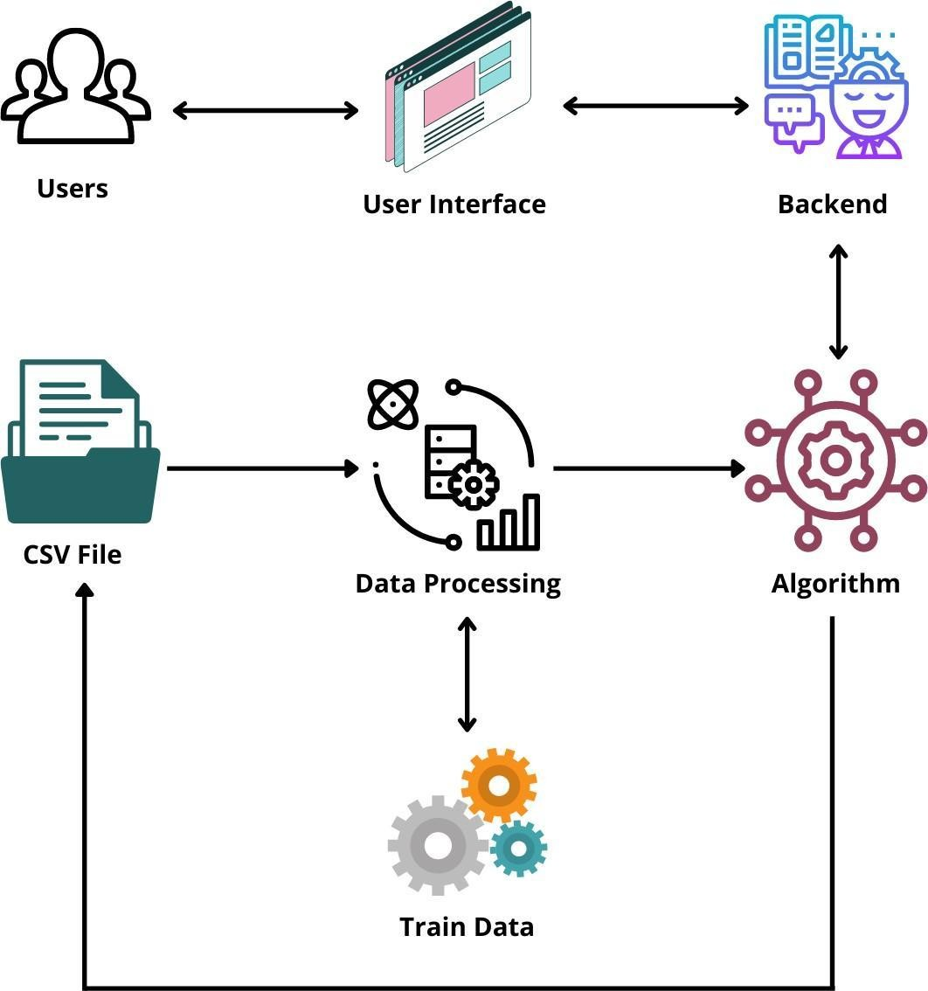

# IDEATION & PROPOSED SOLUTION

* 1. 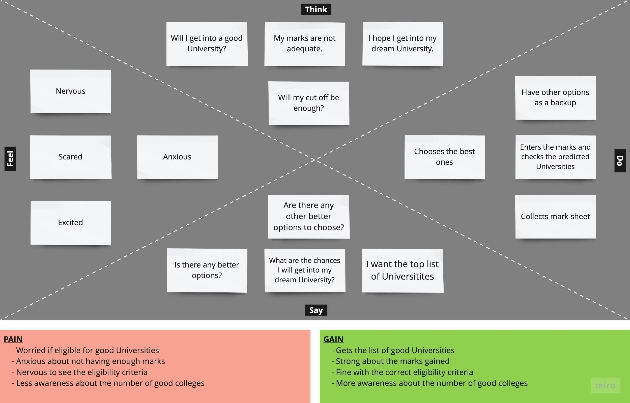Empathy Map Canvas
  2. **Ideation & Brainstorming**

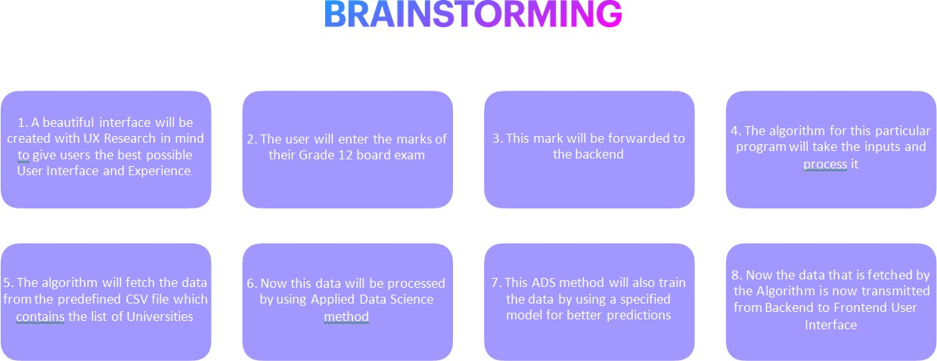

* 1. **Proposed Solution**

**Proposed Solution :**

Project team shall fill the following information in proposed solution template.

|  |  |  |
| --- | --- | --- |
| **S.No.** | **Parameter** | **Description** |
| 1. | Problem Statement (Problem to be | Students do not have much idea about the procedures, availability and e universities where they want to join, so they seek help from various  consultancies to help them secure admission in the universities based on  , for which the students are supposed to pay a hefty amount as consultancy fee. |
| 2. | Idea / Solution description | Providing an accurate prediction for the student’s admission into the f their choice based on various parameters like IELTS,  GRE, Academic Performance, etc. |
| 3. | Novelty / Uniqueness | It seems there are no web applications for predicting the eligibility criteria for getting in to their dream university and also requirement of  d insights on specific areas where they can improve their talents and skills. |
| 4. | Social Impact / Customer Satisfaction | It helps student the right decision for choosing the dream universities. Its st of consultancy services by creating a direct connection between the  d their  dream universities. |

|  |  |  |
| --- | --- | --- |
| 5. | Business Model (Revenue Model) | Universities are under the immense pressure to admit more students and ent for the success. To overcome this pressure, they can make use of odels in which it helps them to ease the intake process of  students and improve efficiency. |
| 6. | Scalability of the Solution | Further to reduce the immense pressure faced by the students to get a university, the model can also be involved to consider university for examinations and to maintain the latest  eligibility criteria for students. |

### Problem Solution fit

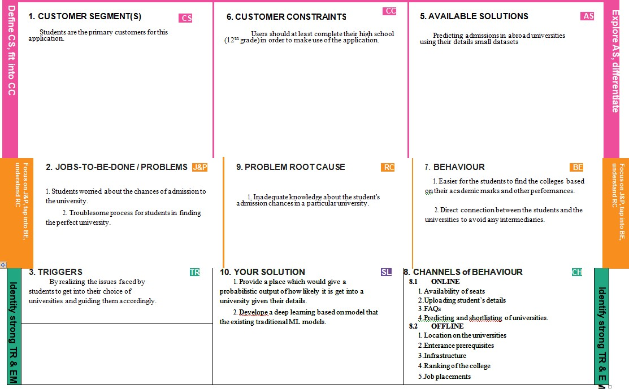

 

### REQUIREMENT ANALYSIS 4.1Functional requirement

Following are the functional requirements of the proposed solution.

|  |  |  |
| --- | --- | --- |
| **FR No.** | **Functional Requirement (Epic)** | **Sub Requirement (Story / Sub-Task)** |
| FR-1 | Landing page | There is no registration from the user end.  The users can access the website with ease, **without worrying about any security** issues. |
| FR-2 | Entering Marks | The users will enter their respective marks that are required. Based on the live data we get from the user, we provide them the list of Universities they are eligible  to attend. |
| FR-3 | List Display | The list of Universities will be displayed based on the marks given. |

4.2 Non-Functional requirements

Following are the non-functional requirements of the proposed solution.

|  |  |  |
| --- | --- | --- |
| **FR No.** | **Non-Functional Requirement** | **Description** |
| NFR-1 | **Usability** | User friendly, with direct instructions and UX  principles considered. |

|  |  |  |
| --- | --- | --- |
| NFR-2 | **Security** | As we don’t get the personal data from the user, their data is protected and there won’t be any leakage. The system gets trained by passing only the  data of marks to the cloud. |
| NFR-3 | **Reliability** | The website is reliable in terms of immediate  information regarding the university decisions. |
| NFR-4 | **Performance** | It is a light application, with a flask in the backend. |
| NFR-5 | **Availability** | It is free of cost and available to anyone who is  looking to find the Universities that fit them and their needs. |
| NFR-6 | **Scalability** | It can be further extended to Higher Education and  abroad studies. |

1. **PROJECT DESIGN**

### Data Flow Diagrams

A Data Flow Diagram (DFD) is a traditional visual representation of the information flows within a system. A neat and clear DFD can depict the right amount of the system requirement graphically. It shows how data enters and leaves the system, what changes the information, and where data is stored.

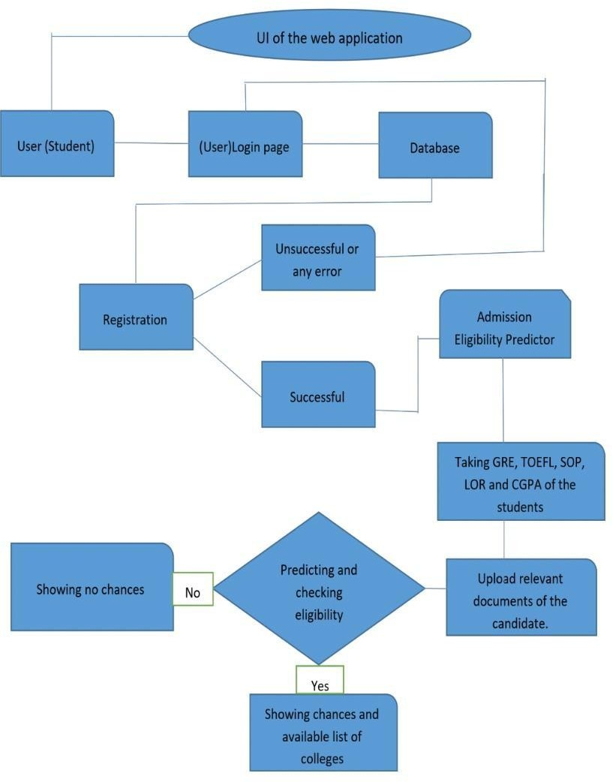

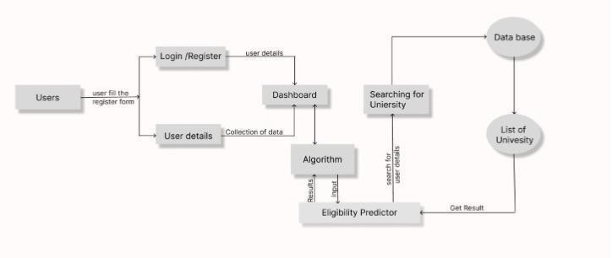

***User Stories***

|  |  |  |  |  |  |  |
| --- | --- | --- | --- | --- | --- | --- |
| **User Type** | **Functi**  **onal** | **User**  **Story** | **User Story / Task** | **Acceptance criteria** | **Priority** | **Release** |
|  | **Requir** | **Numb** |  |  |  |  |
|  | **ement (Epic)** | **er** |  |  |  |  |
| Customer 1 (Web  user) | Landing Page | USN-1 | It is pretty clear about why we use this website and how it should be  used, just by looking at this page. | Understandable | High | Sprint-1 |
| Customer 2 | Landing Page | USN-2 | The concept of the application is | Very clear | High | Sprint-1 |
| (Web User) |  |  | clear with all |  |  |  |
|  |  |  | the how to do instructions and |  |  |  |
|  |  |  | everything. |  |  |  |
| Customer 3 (Web  User) | Marks page | USN-3 | Its pretty clear what kind of data should be given in. | I can give my marks  details. | Low | Sprint-2 |

|  |  |  |  |  |  |  |
| --- | --- | --- | --- | --- | --- | --- |
| Customer 4 (Web User) | Results Page | USN-4 | I can see the right and correct results based  on the marks given to the system | Got the details | High | Sprint-1 |

### Solution & Technical Architecture

**Architecture Diagram:**

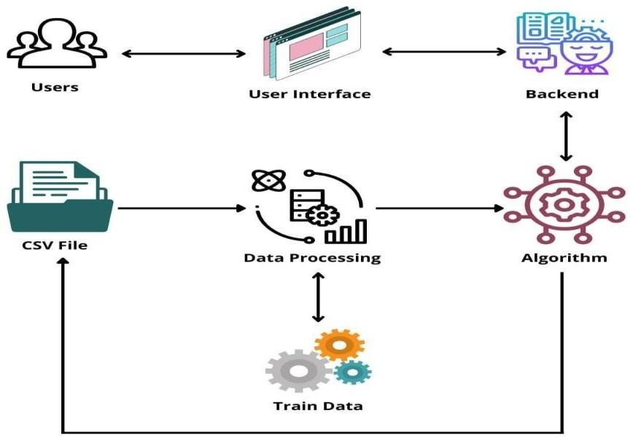

## Solution Architecture :

Students are often worried about their chances of admission to University.

The aim of this project is to help students in shortlisting universities with their profiles.

The predicted output gives them a fair idea about their admission chances to a particular university.

This analysis should also help students who are currently preparing or will be preparing to get a better idea.

### User Stories

|  |  |  |  |  |  |  |
| --- | --- | --- | --- | --- | --- | --- |
| **User Type** | **Functional Requireme nt (Epic)** | **User Story Numbe**  **r** | **User Story / Task** | **Acceptance criteria** | **Priority** | **Release** |
| Customer 1 (Web user) | Landing Page | USN-1 | It is pretty clear about why we use this website and how it should be used, just by looking  at this page. | Understandable | High | Sprint-1 |
| Customer 2 (Web User) | Landing Page | USN-2 | The concept of the application is clear with all the how to do instructions and everything. | Very clear | High | Sprint-1 |
| Customer 3 (Web  User) | Marks page | USN-3 | Its pretty clear what kind of data should be given in. | I can give my marks details. | Low | Sprint-2 |
| Customer  4 (Web User) | Results Page | USN-4 | I can see the right and correct  results based on the marks given to the system | Got the details | High | Sprint-1 |
|  |  |  |  |  |  |  |

1. **PROJECT PLANNING & SCHEDULING**

#### Sprint Planning & Estimation

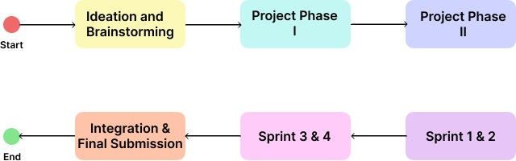

* The sprints started right after our Training session by IBM.
* Though it started then, we started brainstorming our project since the beginning of this semester's calendar.
* We completed the “Ideation and Brainstorming” phase first, moving on to each other phases one by one.
* Each took a task (exactly what we estimated) to complete.
* First Sprint contains the HTML Code, which acts as a building block for our application.
* Second Sprint is the CSS Code, which enhances the look of the website.
* Third Sprint is the initialization of the flask language and a little bit of backend code. This is where we learned all the important topics needed to complete this project.
* Then the last Sprint, the fourth one, contains only the backend python-flask code, that performs various Data Manipulation and trains the model
  1. Sprint Delivery Schedule

|  |  |  |  |  |  |  |
| --- | --- | --- | --- | --- | --- | --- |
| Sprint | Functional Requirement (Epic) | User Story Number | User Story / Task | Story Points | Priority | Team Member s |
| Sprint-1 | Frontend -  HTML | USN-1 | I’m able to see the tables or  columns where I can inject my marks into. | 2 | Medium | Vino S |
| Sprint-2 | Frontend -  CSS | USN-2 | Now the application looks more  appealing and nice to the eyes. | 1 | Low | Mayakan  nan L |
| Sprint-3 | Flask | USN-3 | I can see that my data is being processed. | 2 | Medium | Shruthi PG |
| Sprint-4 | Python | USN-4 | I can get the results from the  inputs I have given to the system. | 2 | High | Sindhuja |

|  |  |  |  |  |  |  |
| --- | --- | --- | --- | --- | --- | --- |
| Sprint | Total Story Points | Duratio n | Sprint Start Date | Sprint End Date (Planned) | Story Points Completed (as on Planned End Date) | Sprint Release Date (Actual) |
| Sprint-1 | 20 | 6 Days | 24 Oct 2022 | 29 Oct 2022 | 20 | 17.11.22 |
| Sprint-2 | 20 | 6 Days | 31 Oct 2022 | 05 Nov 2022 | 20 | 17.11.22 |
| Sprint-3 | 20 | 6 Days | 07 Nov 2022 | 12 Nov 2022 | 20 | 17.11.22 |
| Sprint-4 | 20 | 6 Days | 14 Nov 2022 | 19 Nov 2022 | 20 | 17.11.22 |

### CODING & SOLUTIONING

* 1. **Feature 1**

### HTML CODE:

<!DOCTYPE html>

<html lang="en">

<head>

<meta charset="UTF-8">

<meta name="viewport" content="width=device-width, initial-scale=1.0">

<meta http-equiv="X-UA-Compatible" content="ie=edge">

<title>Login</title>

<link rel="stylesheet" href="login-style.css">

<link href="https://fonts.googleapis.com/css?family=Raleway:700,500,1000&display=sw ap" rel="stylesheet">

<script type="text/javascript" [src="http://ajax.googleapis.com/ajax/libs/jquery/1.6.2/jquery.min.js">](http://ajax.googleapis.com/ajax/libs/jquery/1.6.2/jquery.min.js)

</script>

<script>

$(function() {

var people = [];

$.getJSON(' https://api.thingspeak.com/channels/1013258/feeds.json?results=1', function(data) {

$.each(data.feeds, function(i, f) {

var tblRow = "<tr>" + "<td>" + f.created_at + "</td>" +"<td>" + f.entry_id + "</td>" + "<td>" + f.field8 + "</td>"+"</tr>"

$(tblRow).appendTo("#userdata tbody");

});

});

});

</script>

</head>

<body>

<main>

<div class="background">

<div class="text">

<center style="color:blue">

<h1>PREDICTING COLLEGES</h1>

</center><br>

<center>

<form action="https://api.thingspeak.com/update?api_key=QNRWO798ZZV2OEIL&" method="post" target="_blank">

GRE Score :<input type="text" name="field1"><br><br>

TOEFL Score :<input type="text" name="field2"><br><br>

University Rating :<input type="text" name="field3"><br><br>

SOP :<input type="text" name="field4"><br><br>

LOR :<input type="text" name="field5"><br><br>

CGPA :<input type="text" name="field6"><br><br>

Research :<input type="text" name="field7"><br><br>

<button type="submit">SUBMIT</button>

</form>

<br>

<br>

<br>

<br>

<br>

<br>

<br>

<br>

<br>

<table id= "userdata" border="2">

<thead>

<th>Date</th>

<th>S.no</th>

<th>COLLAGES</th>

</thead>

<tbody>

</tbody>

</table>

<iframe id='track' frameborder="0" scrolling="no" width="1" height="1">

</script>

</center>

</div>

</div>

</main>

</body>

</html>

#### CSS CODE:

*{

margin: 0;

padding: 0;

box-sizing: border-box; text-decoration: none;

}

body{

font-family: 'Raleway', sans-serif; background: #000;

}

.background{

background: url(background.jpeg) no-repeat; background-position: center top;

background-size: contain; height:2200px; position:relative

display: flex;

}

.text, .box{

margin-top:0vh; flex: 1;

}

.text{

margin-left: 0%; font-weight: 200px;

color:white;

}

.box{

margin-right: 25%;

}

.text h1{

font-size: 70px; color: #fff;

font-weight: 500;

}

.text h2{

font-size: 70px; color: #fff;

font-weight: 500;

}

.text p{

font-size: 20px; color: #fff;

font-weight: 300;

}

.text p a{

color: #fff;

font-weight: 700;

}

.form{

background: transparent; color: #fff;

box-sizing: border-box; display: flex;

flex-direction: column; width: 250px;

}

input{

margin: 20px 0; padding: 10px;

background: transparent; border: none;

outline: none; color: #fff;

font-family: 'Raleway', sans-serif;

}

.username, .password{

border-bottom: 1px solid #fff;

}

.button{

background: transparent; border: 1px solid #fff; color: #fff;

font-size: 18px;

}

.button:hover{ background: #000; color: #fff;

}

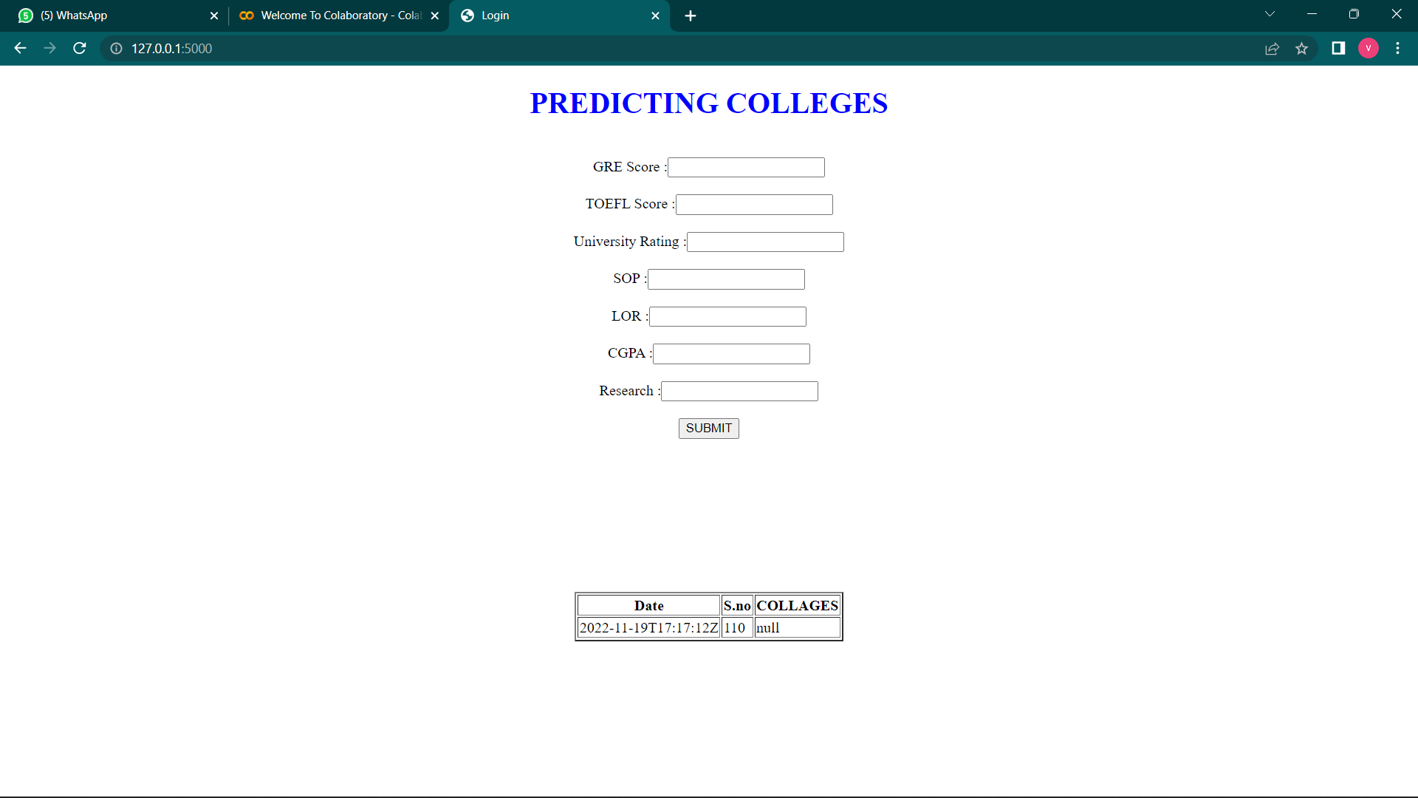

* 1. **Feature 2**

college.ipynb

import numpy as np import pandas as pd

from sklearn import metrics

from sklearn.model_selection import train_test_split import matplotlib.pyplot as plt

import seaborn as sns import pickle

data = pd.read_csv('data.csv') data.head()

data.shape

X = data.iloc[:,:-1] X.head()

y = data.iloc[:,-1] y.head()

print(X) print(y)

data['Chance of Admit '].value_counts()

X_train,X_test,y_train,y_test = train_test_split(X,y,test_size=0.3,random_state=1) sns.countplot(x='Chance of Admit ',data=data)

plt.show() X_train.shape X_train.head() y_test.shape y_test.head()

from sklearn.metrics import accuracy_score max_accuracy = 0

from sklearn.neighbors import KNeighborsClassifier

for x in range(1,100):

model = KNeighborsClassifier(n_neighbors=x)

model.fit(X_train,y_train)

y_pred = model.predict(X_test)

current_accuracy = round(accuracy_score(y_pred,y_test)*100,2)

if(current_accuracy>max_accuracy):

max_accuracy = current_accuracy

best_x = x

*#print(max_accuracy)*

print(best_x)

model = KNeighborsClassifier(n_neighbors=best_x) model.fit(X_train,y_train)

y_pred = model.predict(X_test) filename = 'knn.sav'

pickle.dump(model, open(filename, 'wb')) acc=(metrics.accuracy_score(y_pred,y_test)*100) print("Accuracy is:",acc)

cm1 = metrics.confusion_matrix(y_pred,y_test)

total1=sum(sum(cm1))

sensitivity1 = cm1[0,0]/(cm1[0,0]+cm1[0,1]) print('Sensitivity : ', sensitivity1 )

specificity1 = cm1[1,1]/(cm1[1,0]+cm1[1,1]) print('Specificity : ', specificity1)

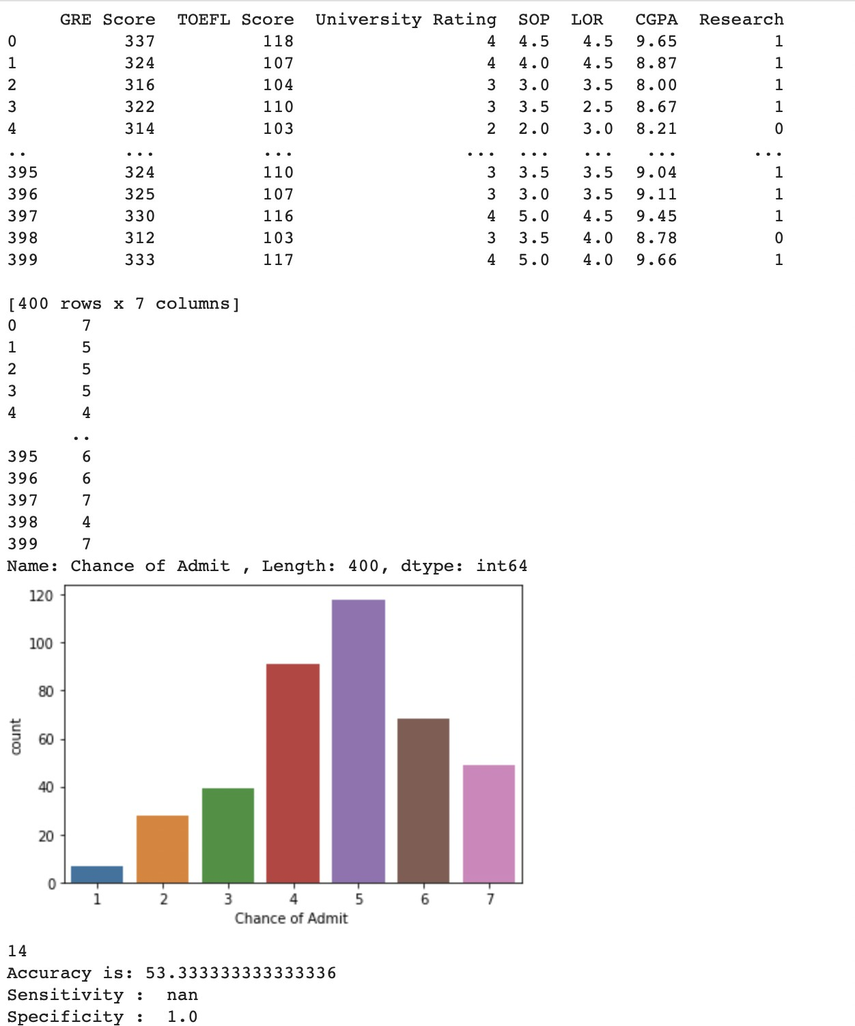

import pickle import urllib.request import json

from time import sleep while True:

conn = urllib.request.urlopen("https://api.thingspeak.com/channels/1013258/feeds.json?resu lts=1")

response = conn.read()

print ("http status code=%s" % (conn.getcode()))

data=json.loads(response)

x=int(data['feeds'][0]['entry_id'])

y=x

conn.close()

while x==y:

conn = urllib.request.urlopen("https://api.thingspeak.com/channels/1013258/feeds.json?resu lts=1")

response = conn.read()

*#print ("http status code=%s" % (conn.getcode()))*

data=json.loads(response)

y=int(data['feeds'][0]['entry_id'])

conn.close()

conn = urllib.request.urlopen("https://api.thingspeak.com/channels/1013258/feeds.json?resu lts=1")

response = conn.read()

print ("http status code=%s" % (conn.getcode()))

data=json.loads(response)

a=float(data['feeds'][0]['field1'])

b=float(data['feeds'][0]['field2'])

c=float(data['feeds'][0]['field3'])

d=float(data['feeds'][0]['field4'])

e=float(data['feeds'][0]['field5'])

f=float(data['feeds'][0]['field6'])

g=float(data['feeds'][0]['field7'])

conn.close()

filename = 'knn.sav'

loaded_model = pickle.load(open(filename, 'rb'))

person_reports = [[a,b,c,d,e,f,g]]

predicted = loaded_model.predict(person_reports)

print("ANALYSING ")

print(predicted[0])

sleep(15)

if predicted[0]==1:

conn = urllib.request.urlopen("https://api.thingspeak.com/update?api_key=QNRWO798ZZV2OEIL& field8=1-VIT

1. JPR
2. AGNI")

elif predicted[0]==2:

conn = urllib.request.urlopen("https://api.thingspeak.com/update?api_key=QNRWO798ZZV2OEIL& field8=1-SREC

1. KEC
2. KPR")

elif predicted[0]==3:

conn = urllib.request.urlopen("https://api.thingspeak.com/update?api_key=QNRWO798ZZV2OEIL& field8=1-KONGU

1. KCT
2. HIT")

elif predicted[0]==4:

conn = urllib.request.urlopen("https://api.thingspeak.com/update?api_key=QNRWO798ZZV2OEIL& field8=1-SASTHRA

1. SKCET
2. BIT")

elif predicted[0]==5:

conn = urllib.request.urlopen("https://api.thingspeak.com/update?api_key=QNRWO798ZZV2OEIL& field8=1-SRM

1. THIAGARAJAR
2. NIIT")

elif predicted[0]==6:

conn = urllib.request.urlopen("https://api.thingspeak.com/update?api_key=QNRWO798ZZV2OEIL& field8=1-PSG

1. CIT
2. GCT")

elif predicted[0]==7:

conn = urllib.request.urlopen("https://api.thingspeak.com/update?api_key=QNRWO798ZZV2OEIL& field8=1-IIT

1. MIT
2. ANNA_UNIVERSITY-CHE")

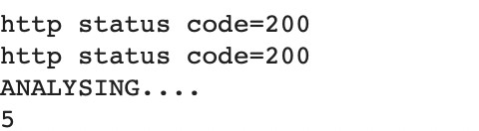

##### Integration:

from flask import Flask, render_template app = Flask( name )

import os

import subprocess @app.route(r'/') def index():

return render_template('login.html')

if name == ' main ': app.run(debug=True)

1. TESTING
   1. Test Cases





- All the test cases got passed and the expected output is received as the result.

* 1. User Acceptance Testing

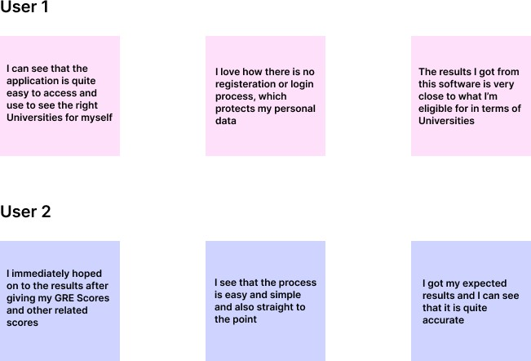

1. RESULTS
   1. Performance Metrics

The data is trained and tested with all three algorithms and out of all KNN gave more accuracy with 90.3 percent and then the KNN with 88.33 percent accuracy. As KNN gave the highest accuracy, all further data predictions are chosen to be followed with KNN. So, finally a web application is made to give the input parameters of the student and the final

prediction is generated and displayed. The background algorithm being used is KNN and the new prediction are keep on adding to the dataset for further more accuracy.

1. CONCLUSION

It has been concluded that the software system that we built is successfully executing our aim. The students that are willing to get into a great college, use this website to get more awareness. All this features given to the users at ease, without collecting any of their personal data expect the marks, which we use to train the system, to produce more better and accurate result as we go.

1. FUTURE SCOPE

A powerful web application can be developed where inputs are not given directly instead student parameters are taken by evaluating students through various evaluations and examinations. Technical, analytical, logical, memory based, psychometry and general awareness, interests and skill based tests can be designed and parameters are collected through them so that results will be certainly accurate and the system will be more reliable to use.

Also KNNs have few limitations like overfitting, no pruning, lack of capability to deal with null and missing values and few algorithms have problem with huge number of values. All these can be taken into consideration and even more reliable and more accurate algorithms can be used. Then the project will be more powerful to depend upon and even more efficient to depend upon.

### APPENDIX

#### Source Code:

##### Login.html

<!DOCTYPE html>

<html lang="en">

<head>

<meta charset="UTF-8">

<meta name="viewport" content="width=device-width, initial-scale=1.0">

<meta http-equiv="X-UA-Compatible" content="ie=edge">

<title>Login</title>

<link rel="stylesheet" href="login-style.css">

<link href="https://fonts.googleapis.com/css?family=Raleway:700,500,1000&display=sw ap" rel="stylesheet">

<script type="text/javascript" [src="http://ajax.googleapis.com/ajax/libs/jquery/1.6.2/jquery.min.js">](http://ajax.googleapis.com/ajax/libs/jquery/1.6.2/jquery.min.js)

</script>

<script>

$(function() {

var people = [];

$.getJSON(' https://api.thingspeak.com/channels/1013258/feeds.json?results=1', function(data) {

$.each(data.feeds, function(i, f) {

var tblRow = "<tr>" + "<td>" + f.created_at + "</td>" +"<td>" + f.entry_id + "</td>" + "<td>" + f.field8 + "</td>"+"</tr>"

$(tblRow).appendTo("#userdata tbody");

});

});

});

</script>

</head>

<body>

<main>

<div class="background">

<div class="text">

<center style="color:blue">

<h1>PREDICTING COLLEGES</h1>

</center><br>

<center>

<form action="https://api.thingspeak.com/update?api_key=QNRWO798ZZV2OEIL&" method="post" target="_blank">

GRE Score :<input type="text" name="field1"><br><br>

TOEFL Score :<input type="text" name="field2"><br><br>

University Rating :<input type="text" name="field3"><br><br>

SOP :<input type="text" name="field4"><br><br>

LOR :<input type="text" name="field5"><br><br>

CGPA :<input type="text" name="field6"><br><br>

Research :<input type="text" name="field7"><br><br>

<button type="submit">SUBMIT</button>

</form>

<br>

<br>

<br>

<br>

<br>

<br>

<br>

<br>

<br>

<table id= "userdata" border="2">

<thead>

<th>Date</th>

<th>S.no</th>

<th>COLLAGES</th>

</thead>

<tbody>

</tbody>

</table>

<iframe id='track' frameborder="0" scrolling="no" width="1" height="1">

</script>

</center>

</div>

</div>

</main>

</body>

</html>

##### Login-style.css:

*{

margin: 0;

padding: 0;

box-sizing: border-box; text-decoration: none;

}

body{

font-family: 'Raleway', sans-serif; background: #000;

}

.background{

background: url(background.jpeg) no-repeat; background-position: center top;

background-size: contain; height:2200px; position:relative

display: flex;

}

.text, .box{

margin-top:0vh; flex: 1;

}

.text{

margin-left: 0%; font-weight: 200px;

color:white;

}

.box{

margin-right: 25%;

}

.text h1{

font-size: 70px; color: #fff;

font-weight: 500;

}

.text h2{

font-size: 70px; color: #fff;

font-weight: 500;

}

.text p{

font-size: 20px; color: #fff;

font-weight: 300;

}

.text p a{

color: #fff;

font-weight: 700;

}

.form{

background: transparent; color: #fff;

box-sizing: border-box; display: flex;

flex-direction: column; width: 250px;

}

input{

margin: 20px 0; padding: 10px;

background: transparent; border: none;

outline: none; color: #fff;

font-family: 'Raleway', sans-serif;

}

.username, .password{

border-bottom: 1px solid #fff;

}

.button{

background: transparent; border: 1px solid #fff; color: #fff;

font-size: 18px;

}

.button:hover{ background: #000; color: #fff;

}

##### Server.py

from flask import Flask, render_template app = Flask( name )

import os

import subprocess @app.route(r'/') def index():

return render_template('login.html')

if name == ' main ': app.run(debug=True)

College.ipynb (i)

**import** numpy **as** np **import** pandas **as** pd

**from** sklearn **import** metrics

**from** sklearn.model_selection **import** train_test_split **import** matplotlib.pyplot **as** plt

**import** seaborn **as** sns **import** pickle

data **=** pd**.**read_csv('data.csv') data**.**head()

data**.**shape

X **=** data**.**iloc[:,:**-**1] X**.**head()

y **=** data**.**iloc[:,**-**1] y**.**head()

print(X) print(y)

data['Chance of Admit ']**.**value_counts()

X_train,X_test,y_train,y_test **=** train_test_split(X,y,test_size**=**0.3,random_state**=**1) sns**.**countplot(x**=**'Chance of Admit ',data**=**data)

plt**.**show() X_train**.**shape

X_train**.**head() y_test**.**shape y_test**.**head()

**from** sklearn.metrics **import** accuracy_score max_accuracy **=** 0

**from** sklearn.neighbors **import** KNeighborsClassifier

**for** x **in** range(1,100):

model **=** KNeighborsClassifier(n_neighbors**=**x)

model**.**fit(X_train,y_train)

y_pred **=** model**.**predict(X_test)

current_accuracy **=** round(accuracy_score(y_pred,y_test)**\***100,2)

**if**(current_accuracy**>**max_accuracy):

max_accuracy **=** current_accuracy

best_x **=** x

*#print(max_accuracy)*

print(best_x)

model **=** KNeighborsClassifier(n_neighbors**=**best_x) model**.**fit(X_train,y_train)

y_pred **=** model**.**predict(X_test) filename **=** 'knn.sav'

pickle**.**dump(model, open(filename, 'wb')) acc**=**(metrics**.**accuracy_score(y_pred,y_test)**\***100) print("Accuracy is:",acc)

cm1 **=** metrics**.**confusion_matrix(y_pred,y_test)

total1**=**sum(sum(cm1))

sensitivity1 **=** cm1[0,0]**/**(cm1[0,0]**+**cm1[0,1]) print('Sensitivity : ', sensitivity1 )

specificity1 **=** cm1[1,1]**/**(cm1[1,0]**+**cm1[1,1]) print('Specificity : ', specificity1)

(ii)

**import** pickle **import** urllib.request **import** json

**from** time **import** sleep **while True**:

conn **=** urllib**.**request**.**urlopen("https://api.thingspeak.com/channels/1013258/feeds.json?results=1")

response **=** conn**.**read()

print ("http status code=%s" **%** (conn**.**getcode()))

data**=**json**.**loads(response)

x**=**int(data['feeds'][0]['entry_id'])

y**=**x

conn**.**close()

**while** x**==**y:

conn **=** urllib**.**request**.**urlopen("https://api.thingspeak.com/channels/1013258/feeds.json?results=1")

response **=** conn**.**read()

*#print ("http status code=%s" % (conn.getcode()))*

data**=**json**.**loads(response)

y**=**int(data['feeds'][0]['entry_id'])

conn**.**close()

conn **=** urllib**.**request**.**urlopen("https://api.thingspeak.com/channels/1013258/feeds.json?results=1")

response **=** conn**.**read()

print ("http status code=%s" **%** (conn**.**getcode()))

data**=**json**.**loads(response)

a**=**float(data['feeds'][0]['field1'])

b**=**float(data['feeds'][0]['field2'])

c**=**float(data['feeds'][0]['field3'])

d**=**float(data['feeds'][0]['field4'])

e**=**float(data['feeds'][0]['field5'])

f**=**float(data['feeds'][0]['field6'])

g**=**float(data['feeds'][0]['field7'])

conn**.**close()

filename **=** 'knn.sav'

loaded_model **=** pickle**.**load(open(filename, 'rb'))

person_reports **=** [[a,b,c,d,e,f,g]]

predicted **=** loaded_model**.**predict(person_reports)

print("ANALYSING ")

print(predicted[0])

sleep(15)

**if** predicted[0]**==**1:

conn **=** urllib**.**request**.**urlopen("https://api.thingspeak.com/update?api_key=QNRWO798ZZV2OEIL&field8=1-VIT

1. JPR
2. AGNI")

**elif** predicted[0]**==**2:

conn **=**

urllib**.**request**.**urlopen("https://api.thingspeak.com/update?api_key=QNRWO798ZZV2OEIL&field8=1-SREC 2-KEC

3-KPR")

**elif** predicted[0]**==**3:

conn **=**

urllib**.**request**.**urlopen("https://api.thingspeak.com/update?api_key=QNRWO798ZZV2OEIL&field8=1-KONGU 2-KCT

3-HIT")

**elif** predicted[0]**==**4:

conn **=**

urllib**.**request**.**urlopen("https://api.thingspeak.com/update?api_key=QNRWO798ZZV2OEIL&field8=1-SASTHR A

1. SKCET
2. BIT")

**elif** predicted[0]**==**5:

conn **=**

urllib**.**request**.**urlopen("https://api.thingspeak.com/update?api_key=QNRWO798ZZV2OEIL&field8=1-SRM 2-THIAGARAJAR

3-NIIT")

**elif** predicted[0]**==**6:

conn **=**

urllib**.**request**.**urlopen("https://api.thingspeak.com/update?api_key=QNRWO798ZZV2OEIL&field8=1-PSG 2-CIT

3-GCT")

**elif** predicted[0]**==**7:

conn **=**

urllib**.**request**.**urlopen("https://api.thingspeak.com/update?api_key=QNRWO798ZZV2OEIL&field8=1-IIT 2-MIT

3-ANNA_UNIVERSITY-CHE")

### GitHub & Project Demo Link

Github: <https://github.com/IBM-EPBL/IBM-Project-39025-1660389388>

Project Demo Link: <https://youtu.be/J_mlJmjV6cY>